**HTML <mark> Tag**

Last Updated : 26 Sep, 2024

**The <mark> tag in HTML** is used to define the marked text. It is used to highlight the part of the text in a paragraph. The <mark> tag is new in HTML 5.

**Syntax:**

<mark> Contents... </mark>

***Note:*** *The <mark> tag also supports the*[*Global Attributes*](https://www.geeksforgeeks.org/html-global-attributes/) *and* [*Event Attributes*](https://www.geeksforgeeks.org/html-event-attributes-complete-reference/) *in HTML.*

**Example 1:** In this example, we are using the <mark> tag to highlight specific text, such as “GeeksforGeeks” and “computer science,” within a paragraph. The highlighted text is visually emphasized for readers.



1

<!DOCTYPE html>

2

<html>

3

​

4

<body>

5

<h1 style="color: green;">GeeksforGeeks</h1>

6

<h2>HTML mark Tag</h2>

7

<p>

8

<mark>GeeksforGeeks:</mark> It is a

9

<mark>computer science</mark> portal for geeks

10

</p>

11

</body>

12

​

13

</html>

**Output:**

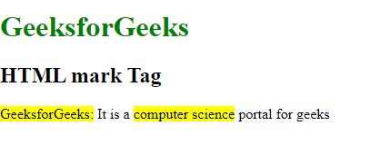

**Example** **2:**In this example we are using the <mark> tag with custom styling to highlight “GeeksforGeeks” and “computer science,” changing the background to green and text color to white for emphasis.



1

<!DOCTYPE html>

2

<html>

3

​

4

<body>

5

<h1>GeeksforGeeks</h1>

6

<h2> HTML mark Tag</h2>

7

<p>

8

<mark>GeeksforGeeks:</mark> It is a

9

<mark style="background-color: green; color: white;">

10

computer science

11

</mark> portal for geeks

12

</p>

13

</body>

14

​

15

</html>

**Output:**

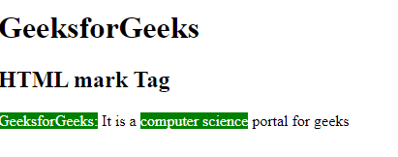

**Supported Browsers:**

* [Google Chrome](https://www.geeksforgeeks.org/google-chrome-browser/)
* [Edge](https://www.geeksforgeeks.org/microsoft-edge-browser/)
* [Firefox](https://www.geeksforgeeks.org/mozilla-firefox-browser/)
* [Opera](https://www.geeksforgeeks.org/opera-browser/)
* [Safari](https://www.geeksforgeeks.org/apple-safari-browser/)

**HTML <mark> Tag – FAQs**

**What is the purpose of the <mark> tag in HTML?**

*The <mark> tag is used to highlight text that is of special relevance or importance within a document. It’s often rendered with a yellow background by default.*

**How does the <mark> tag differ from other text formatting tags?**

*Unlike tags like <strong> or <em>, which indicate importance or emphasis, the <mark> tag specifically denotes highlighted text, making it clear that the content has a special significance in the context of the surrounding text.*

**Can I style the <mark> tag usi**